DD Richards, Senior Consultant, Training, ESRI

DD Richards is a Senior Consultant at Esri specializing in Learning and Skills Development, where she helps individuals and organizations build the knowledge, skills, and confidence needed to succeed with GIS. Based at Esri headquarters in Redlands, California, DD has been with Esri for two years, partnering with customers to drive meaningful outcomes through effective training and workforce development. Prior to joining Esri, DD served as Vice President of Sales and Marketing for a Fortune 300 company that leveraged GIS and Esri technology to produce natural and environmental hazards reports for the real estate industry. In this role, she bridged complex spatial data with real-world decision-making, helping organizations translate geospatial insight into practical action. DD also brings hands-on experience in public safety. Following a plane crash in 2017, she became actively involved with a local airport and pilots association and joined the Disaster Airlift Response Team. In this capacity, she played a key role in planning and executing critical missions in response to disaster events. As your dedicated training consultant, DD is deeply committed to professional development and excited to partner with you. She brings a combination of expertise, practical experience, and personalized support to help you build skills, strengthen capability, and realize the full value of Esri technology.
Email: Drichards@Esri.com
LinkedIn: https://www.linkedin.com/in/denean-richards-9689267/

Kristina Horn, Manager, Artificial Intelligence Initiative, CLAOC
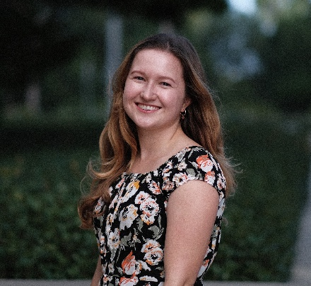
Kristina Horn serves as the Manager of the Artificial Intelligence Initiative at CEO Leadership Alliance Orange County (CLAOC), where she leads programs connecting talent to careers in AI, supports local and state AI policy efforts, and fosters collaboration across education, industry, and government. She is also a lecturer at Chapman University, where she teaches undergraduate and graduate courses on AI ethics and technical writing. Since Spring 2025, she has been a research group member and team leader at the Center for AI and Digital Policy, focusing on ethical frameworks, democratic values, and human rights.
Email:
LinkedIn: https://www.linkedin.com/in/kristina-horn-aab76880/

Tim Steed, Assistant General Manager, OCEA
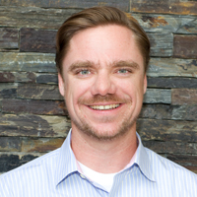
Tim Steed is the Assistant General Manager of the Orange County Employees Association (OCEA). Tim is a proud product of Orange County. He attended public school in Orange County and completed his undergraduate work at the University of California in Irvine, studying Political Science. Tim’s current role at the Orange County Employees Association is where he is most passionate. Tim is a member of OCEA’s Leadership Team where he oversees strategic organizing campaigns that focus on developing leaders from among OCEA’s ranks, increasing the strength and solidarity among OCEA members, and adding new members to the OCEA family. He is leading the OCEA Legislative Committee, and he has experience in labor workforce and legislative issues regarding AI integration to the workforce. Tim joined OCEA in 2007 after serving as a staff member in several political campaigns and participating in numerous union organizing drives throughout California. He also serves on the Executive Board for the California Labor Federation, representing 2.1 million workers.
Email:

